**TASK 1**



**Low fidelity wireframe**

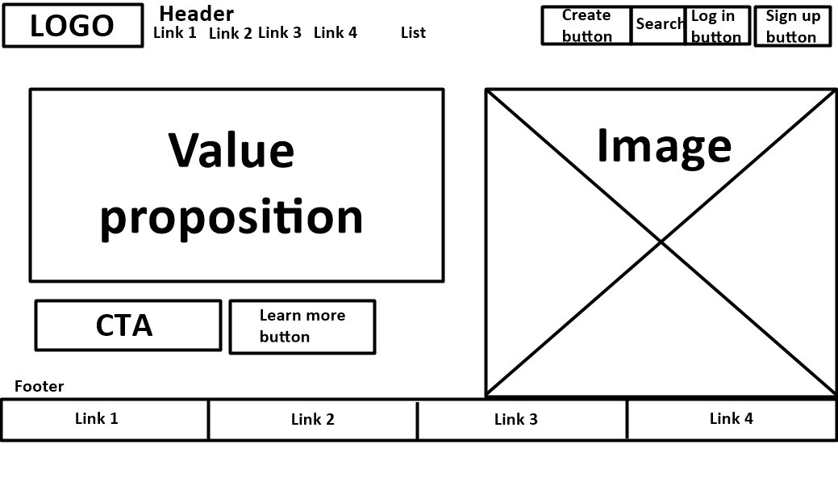

**TASK 2**

* <https://timmyomahony.com/>: rgb(229, 231, 235), rgb(0, 0, 0), rgb(114, 100, 92)

**TASK 3**

**Youtube:**

* Unregistered users:
  + Search videos, channels, playlists…
  + Watch videos
  + Share videos
* Registered users:
  + Unregistered user features +…
  + Subscribe on channels
  + Like/dislike, comment and report videos
  + Create playlists
  + Save videos to watch later
* Content creators:
  + Registered user features +…
  + See channel stats
  + Review comments
  + Promote videos

**TASK 4**

Facebook: connect people from the world by creating communities.

Twitter (X): provide people a free and safe space to talk.

Google: organize information from the internet and make it more accessible to everyone.

Youtube: give everyone the opportunity to express and see the world.